Mrs. Dillon Website: mrsdillonshistorysite.weebly.com
dillonp@mdusd.org
Twitter: @MrsDillonNHS

AP European History
Course Syllabus

Course Description

AP European History is a challenging college-level course that is structured around the investigation of 7 course themes and 19 key concepts in 4 different chronological periods from the Renaissance to the present. Besides covering the relevant historical facts from these eras and linking these facts to the analysis of the themes, the course requires you to master nine historical thinking skills. During the year, you will be provided with the opportunity to examine primary sources, such as documentary material, pictures and graphs, maps, political cartoons, statistical tables, and works of art. In addition, you will be provided with exposure to both factual narratives and to the interpretations of European history from the perspectives of a variety of different writers and historians. Historiography is the history of history. You will be examining how people have thought about and written about historical events over the course of time. You will also be provided with the opportunity to develop your analytical and interpretive writing skills, practicing short answer questions as well as document-based and long essay question essays. Besides the short answer questions, you will me writing at least one essay in each unit.

This course includes history as both content and methodology. Students must demonstrate knowledge of basic chronology and major events and trends since the High Renaissance, and will develop academic skills, including 1.) Effective analysis of such primary sources as documents, maps, statistics, art, pictures, and graphs; 2.) Effective note-taking; 3.) Clear and precise written expression; and 4.) The ability to weigh evidence and reach conclusions on the basis of fact.

Themes that are addressed in the course:

1. Interaction of Europe and the World (INT)
2. Economic and Commercial Developments (ECD)
3. Cultural and Intellectual Developments (CID)
4. States and Other Institutions of Power (SOP)
5. Social Organization and Development (SCD)
6. National and European Identity (NEI)
7. Technological and Scientific Innovation (TSI)

AP Historical Thinking Skills:
- Developments and Processes
  - Identify and explain historical developments and processes.
- Sourcing and Situation
  - Analyze sourcing and situation of primary and secondary sources.
- Claims and Evidence in Sourcing
  - Analyze arguments in primary and secondary sources.
- Contextualization
  - Analyze the context of historical events, developments, or processes.
- Making Connections
  - Using historical reasoning processes (comparison, causation, and continuity and change) analyze patterns and connections between and among historical developments and processes.
- Argumentation
  - Develop an argument.

AP History Reasoning Processes:
- Comparison
  - Describe and explain relative similarities and/or differences between historical developments and processes.
- Causation
  - Describe and explain causes and effects of specific historical developments and processes, as well as the relationship between those causes and effects, the primary and secondary causes, the long-term and short-term effects, and explain how context influenced said historical developments and processes, and its historical significance.
- Continuity and Change Over Time
  - Describe and explain patterns of continuity and/or change over time, as well as the historical significance of specific historical developments in relation to even larger patterns of continuity and change.

Course Format

Guided Reading
The Spielvogel textbook is known as one of the most “student-friendly” textbooks in AP Euro classrooms nationwide, however it may challenge your vocabulary. Use it to your advantage

Primary Source Analysis
For each unit, you will be expected to read, analyze, and interpret a wide variety of primary sources such as:
- Written sources (letters, journals, government documents, newspapers, etc.)
- Maps
- Statistics tables
- Works of art
Secondary sources and Interpretations
Aside from the textbook, we will look at historical scholarship of various viewpoints and historical eras. This will help you develop your own historical interpretation.

APEH Writing
Each unit will give instruction and practice in writing the DBQ (Document-Based Question), SAQ (Short Answer Question) and LEG (Long Essay Question) essays. Some of these will be peer-reviewed, while others will be timed and graded in the AP style.

Simulations, Discussions, and Socratic Seminars
Students will regularly engage in simulations, discussions, and seminars that will require ACTIVE participation, critical thinking, collaboration, and group problem solving.

AP Practice Tests
Each unit will include a summative assessment based upon the AP Exam. These will include AP-style multiple choice questions as well as timed LEQ, SAQ, and DBQ essays.

Key Concepts within Four Chronological Periods:

Unit 1: 1450-1648: The Renaissance, Columbian Exchange, Reformation, and Age of Religious Wars.
Key Concepts:
- 1.1 The rediscovery of works from ancient Greece and Rome and observation of the natural world changed many Europeans’ view of their world.
- 1.2 Religious pluralism challenged the concept of a unified Europe.
- 1.3 Europeans explored and settled overseas territories, encountering and interacting with indigenous populations.
- 1.4 European society and the experiences of everyday life were increasingly shaped by commercial and agricultural capitalism, notwithstanding the continued existence of medieval social and economic structures.

Unit 2: 1648-1815: Absolutism, Constitutional Government, the Scientific Revolution, Transatlantic Economy, Colonial Revolutions, The French Revolution, and Napoleonic Era.
Key Concepts:
- 2.1 Different models of political sovereignty affected the relationship among states and between states and individuals.
- 2.2 The expansion of European commerce accelerated the growth of a worldwide economic network.
- 2.3 The spread of Scientific Revolution concepts and practices and the Enlightenment’s application of these concepts and practices to political, social, and ethical issues led to an increased, although not unchallenged, emphasis on reason in European culture.
- 2.4 The experiences of everyday life were shaped by demographic, environmental, medical, and technological changes.

Unit 3: 1815-1914: The Conservative Restoration, Industrial Revolution, Revolutions of 1832 and 1848, the new bourgeoisie, realpolitik in Germany and Italy, and New Imperialism in Africa, Asia, and the Middle East.
Key Concepts:
- 3.1 The Industrial Revolution spread from great Britain to the continent, where the state played a greater role in promoting industry.
- 3.2 The experiences of everyday life were shaped by industrialization, depending on the level of industrial development in a particular location.
- 3.3 Political revolutions and the complications resulting from industrialization triggered a range of ideological, governmental, and collective responses.
- 3.4 European states struggled to maintain international stability in an age of nationalism and revolutions.
- 3.5 A variety of motives and methods led to the intensification of European global control and increased tensions among the Great Powers.
- 3.6 European ideas and culture expressed a tension between objectivity and scientific realism on one hand, and subjectivity and individual expression on the other.

Unit 4: 1914 to the Present: World War I, the rise of communism in Russia and the Soviet Union, Economic Collapse, Rise of Totalitarianism, World War II, The Cold War and Decolonization.
Key Concepts:
- 4.1 Total war and political instability in the first half of the 20th century gave way to a polarized state order during the Cold War, and eventually to efforts at transnational union.
- 4.2 The stresses of economic collapse and total war engendered internal conflicts within European states and created conflicting conceptions of the relationship between the individual and the state, as demonstrated in the ideological battle among liberal democracy, communism, and fascism.
- 4.3 During the 20th century, diverse intellectual and cultural movements questioned the existence of objective knowledge, the ability of reason to arrive at truth, and the role of religion in determining moral standards.
- 4.4 Demographic changes, economic growth, total war, disruptions of traditional social patterns, and competing definitions of freedom and justice altered experiences of everyday life.

Required Texts:
- Spielvogel, Jackson. (2018) Western Civilization, Since 1300, AP Edition. 10th edition. Cengage Learning.
- Niccoló Machiavelli, The Prince.

Please note: I expect you to read the assigned readings ahead of time. You cannot rely on me to lecture on what was assigned in the reading. Rather than dictate events to you (“This happened, then that happened”), you must come to class prepared to answer questions about the reading.

Required and Recommended Materials:

- An AP test prep book, if you plan on taking the AP exam in May.
MUST BE PUBLISHED AFTER 2016!!
- A spiral bound notebook exclusively for this class for taking notes on lectures and/or reading.
- A binder for keeping reading materials organized.
- Pens, pencils, and highlighters.
- Post-it notes. You will often want to write notes in your textbook, but since you cannot write in the text, use post-it notes instead to annotate what you read.

Rules and Expectations
- Rule #1: Work Hard
  - Students will arrive on time to class by logging on to Zoom or Google Meet at the beginning of class.
  - Any assignments more than one week late are not entitled to receive credit.
  - If you have a question, please ask. Communication is key, especially during distance learning. Please do so in a timely manner.
- Rule #2: Be Kind
  - This is a difficult time. Distance Learning, along with quarantine and the uncertainties of today, are hard for everyone and we are all learning how to do this together. Please be considerate.
  - Please be kind, courteous, and respectful to yourself and others.
  - Disagreement is fine, and even encouraged, but can be done in a respectful manner.
  - Insults, profanity, racist, sexist, or homophobic slurs will NOT be tolerated.
  - During Distance Learning, you must behave appropriately while on camera. Failure to do so will result in removal from Zoom or Google Meet session.

Classroom Supplies:
Not required but donations are always appreciated.
- Kleenex tissues
- Hand sanitizer
- Scotch tape rolls
- Color marker

Useful Resources and Websites:
- The AP College Board website for students and My AP Classroom: https://apstudent.collegeboard.org/apcourse/ap-european-history
  - Create an account using your MDUSD email account.
  - Join my class with the code you are given in class.

- YouTube’s Crash Course channel: Great history videos by author John Green: http://www.youtube.com/user/crashcourse

- www.khanacademy.org has great tutorial videos as well.

- Tom Richey, an AP Euro teacher from South Carolina, has placed his lectures and rubrics online. Go to www.tomrichey.net to access his lecture videos and review materials.

- Paul Sargent’s AP Euro Bit by Bit YouTube videos: Go to www.youtube.com and search “Paul Sargent AP Euro” to find his “Worldwide Classrooms” series.

Course Planner and Readings: “Napoleon by winter break, Hitler by spring break” is the typical AP Euro teacher’s mantra. We will try to adhere to the following schedule. This is a planned outline for the course calendar, along with selected readings, activities, assignments, and quizzes/tests for each chapter unit. Primary and secondary sources will be assigned for each chapter throughout the year. In addition to the “Selected Readings” we will also be analyzing various styles of art in painting, sculpture, and architecture as a source of historical thought, from the Renaissance through Modern Art.
SEMESTER ONE:

Week 1:
- Introduction, Course Syllabus
- Summer homework due; review of summer homework
- Multiple Choice Quiz on Chapter 11 Summer Reading
- Contextualization: Medieval Sports, Medieval Language
- Football DBQ: Understanding Point-of-View

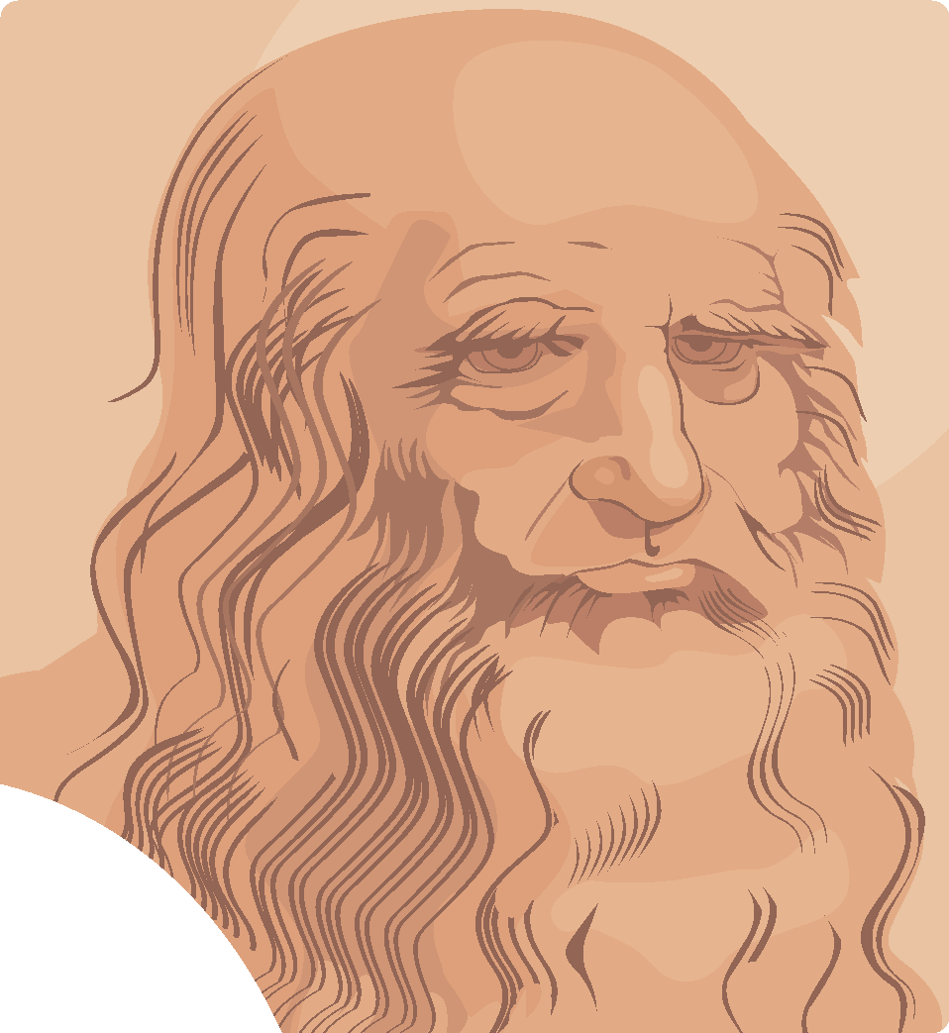
Weeks 2 and 3:
- How to do AP Euro ID’s (Reading Identifications)
- Historical Thinking Skills
- Chapter 12- The Renaissance
  - The Making of Renaissance Society
  - The Italian States in the Renaissance
  - The Intellectual Renaissance
  - The Artistic Renaissance
  - The European State in the Renaissance
  - The Church in the Renaissance
- Selected readings:
  - Petrarch: A Letter to Bocaccio
  - Christine de Pizan: The City of Ladies
  - Castiglione: The Book of the Courtier
  - Peter Paul Vergerio: On the Liberal Arts
  - Pico de la Mirandola: Oration on the Dignity of Man
  - Erasmus: A Humanist Prescription for the Education of Princes.
  - Jacob Burhardt: The Civilization of the Renaissance
  - Peter Burke: The Myth of the Renaissance

Weeks 4 and 5:
- CHAPTER 13:Reformation and the Religious Warfare in the 16th Century
  - Prelude to Reformation
  - Martin Luther and the Reformation in Germany
  - The Spread of the Protestant Reformation
  - The Social Impact of the Protestant Reformation
  - The Catholic Counter-Reformation
  - Politics and the Wars of Religion in the 16th Century
- Selected readings:
  - Erasmus: Julius Exclusus (Julius Excluded From Heaven)- a play
  - Johan Tetzel: Indulgences
  - Martin Luther, Justification of Faith; Bondage of Will; Condemnation of the Peasant Revolt
  - John Calvin: Institutes of the Christian Religion
  - Saint Teresa of Avila: The Way of Perfection
  - Ignatius Loyola: Constitution of the Society of Jesus
  - Several selected secondary sources, including Euan Cameron’s What was the Reformation, G.R. Elton’s A Political Interpretation of the Reformation, and Boxer & Quartert’s Women in the Reformation.
  - Ogier Ghiselin de Busbecq: Civil War in France
  - Cardinal Richelieu: Political Will and Testament
  - John Knox: The First Blast of the Trumpet…
  - The Edict of Nantes, Henry VI of France

Week 6:
- CHAPTER 14: Europe and the World, New Encounters 1500-1800
  - On the Brink of a New World
  - New Horizons: The Portuguese and Spanish Empires
  - New Rivals on the World Stage
  - The Impact of European Expansion
  - Toward a World Economy
- Selected Readings:
  - Christopher Columbus: A Letter to Ferdinand and Isabella
  - Bartolome de las Casas: Amerindians and the Garden of Eden
  - Travels by Marco Polo
  - The Spanish Conquistador: Cortes and the Conquest of Mexico
  - The Atlantic Slave Trade
  - West Meets East: An Exchange of Royal Letters
  - An Imperial Edict to the King of England- Qianlong
  - The Mission- Felix de Azara
- PERIOD 1 UNIT EXAM
- DBQ ESSAY

Weeks 7 and 8:
- CHAPTER 15: State Building and the Search for Order in the 17th Century
  - Social Crises, War, and Rebellions
  - Witch Hunts
  - The Practice of Absolutism: Western Europe
  - Absolutism in Central, Eastern, and Northern Europe
  - Limited Monarchy and Republics
  - The Flourishing of European Culture
- Selected readings:
  - The Hammer of Witches, by Kramer and Spengel
  - The Devil’s Handmaid: Women in the Age of Reformations, by William Monter
  - Hajo Holborn: A Political Interpretation of the Thirty Years War
  - Carl Freidrich: A Religious Interpretation of the Thirty Years War
  - How the Spice Trade Changed the World
  - The Powers of the Monarch in England, by James I
  - The Powers of Parliament in England, by the House of Commons
  - War and Peace in the Old Regime, by M.S. Anderson
  - Memoirs for the Instruction of a Dauphin, by Louis XIV
  - Leviathan, by Thomas Hobbes
  - Second Treatise of Government, by John Locke
  - The Great Czar, by Feofan Prokopovich
  - A Secret Letter: Monarchical Authority in Prussia, by Frederick William
  - Correspondence with Alexis, by Peter the Great

Week 9:
- CHAPTER 16: The Scientific Revolution and the Emergence of Modern Science
  - Background to the Scientific Revolution
  - Toward a New Heaven: A Revolution in Astronomy
  - Advances in Medicine and Chemistry
  - Women in the Origins of Modern Science
  - Toward a New Earth: Descartes, Rationalism, and a New View of Humankind
  - The Scientific Method and the Spread of Scientific Knowledge
- Selected Readings:
  - The Discourse on Method, by Rene Descartes
  - Letter to Christina of Tuscany, by Galileo Galilei
  - Papal Inquisition of 1633: Galileo Condemned
  - Mathematical Principles of Natural Philosophy, by Isaac Newton
  - Nature as a Machine: The Clock, by Steven Shapin
  - Newton’s Rules of Reasoning
  - The Starry Messenger
  - Kepler and the Emerging Scientific Community
  - The Education of Women, by Margaret Cavendish
  - What is a Man in the Infinite? By Pascal

Weeks 10 and 11:
- CHAPTER 17: The 18th Century: An Age of Enlightenment
  - The Enlightenment
  - Culture and Society in the Enlightenment
  - Religion and the Churches
- Selected Readings:
  - What is Enlightenment?, by Immanuel Kant
  - The System of Nature, by Baron d’Holbach
  - Prospectus for the Encyclopedia of Arts and Sciences, by Diderot
  - Philosophical Dictionary: The English Model, by Voltaire
  - Philosophical Dictionary: Religion, by Voltaire
  - The Age of Reason: Deism, by Thomas Paine
  - The Social Contract, by Jean-Jacques Rousseau
  - On Crimes and Punishment, by Cesare Beccaria
  - Women: Especially Constituted to Please Men, by Rousseau
  - A Vindication of the Rights of Women, by Mary Wollstonecraft
- Selected Readings:
  - The Complete English Tradesman, by William Dafoe
  - Letter to Lady R., 1716, by Lady Mary Montagu
  - Women of the Third Estate
  - The Ancien Regime: Ideals and Realities, by John Roberts
  - The Resurgent Aristocracy, by Leonard Krieger
  - Lords and Peasants, by Jerome Blum

Weeks 12 and 13:
- CHAPTER 18: The 18th Century: European States, International Wars, and Social Change
  - The European States
  - Wars and Diplomacy
  - Economic Expansion and Social Change
  - The Social Order of the 18th Century
- Selected Readings:
  - Political Testament, by Frederick the Great
  - In Defense of Mercantilism, by Thomas Nun
  - The Slave Trade, by Anonymous
  - Description of the West Coast of Guinea, by William Bosman
  - A Description of the Middle Passage, by Oloudah Equiano
  - A Speech in the House of Commons in India, 1772, by Sir Robert Clive
  - The Complete English Tradesman, by William Dafoe
  - Letter to Lady R., 1716, by Lady Mary Montagu
  - Women of the Third Estate
  - The Ancien Regime: Ideals and Realities, by John Roberts
  - The Resurgent Aristocracy, by Leonard Krieger
  - Lords and Peasants, by Jerome Blum

Weeks 14-15:
- CHAPTER 19: A Revolution in Politics- The French Revolution and Napoleon
  - The Beginning of the Revolutionary Era: The American Revolution
  - Background to the French Revolution
  - The French Revolution
  - The Age of Napoleon
- Selected Readings:
  - Common Sense, by Thomas Paine
  - Travels in France: Signs of Revolution, by Arthur Young
  - The Cahiers: Discontent of the Third Estate
  - What is the Third Estate? by Abbé Sieyes
  - Declaration of the Rights of Man and of the Citizen
  - Declaration of the Rights of Woman, by Olympe de Gouges
  - A Speech to the National Convention, by Robespierre
  - A Soldier’s Letter to his Mother: Revolutionary Nationalism
  - Memoirs: Napoleon’s Appeal by Madame Remusat
  - Memoirs: Napoleon’s Secret Police by Joseph Fouché
  - Napoleon’s Diary
  - Napoleon’s Proclamation to his Troops in Italy, 1796
  - Napoleon’s Account of the Internal Situation in France, 1804

Week 16:
- CHAPTER 20: The Industrial Revolution and its Impact on European Society
  - The Industrial Revolution in Great Britain
  - The Spread of Industrialization
  - The Social Impact of the Industrial Revolution
- Selected Readings:
  - Testimony for the Factory Act of 1833: Working Conditions in England
  - The Condition of the Working Class in England, by Friedrich Engels
  - The Industrial Revolution in Russia, by Peter Stearns
  - Early Industrial Society: Progress or Decline?
Week 17:
- Finals Week, end of Semester 1
SEMESTER TWO:

Week 18-19:
- CHAPTER 21: Reaction, Revolution, and Romanticism, 1815-1850
  - The Conservative Order
  - The Ideologies of Change
  - Revolution and Reform
  - The Emergence of an Ordered Society
  - Culture in an Age of Reaction and Revolution: The Mood of Romanticism
- Selected readings:
  - Secret Memo to Tsar Alexander I, by Prince Metternich
  - The Carlsbad Decrees
  - Address to Second National Congress, by Simòn Bòlivar
  - The Congress of Vienna, by Hajo Holburn
  - Western Liberalism, by E.K. Bramsted and K.J. Melhuish
  - English Liberalism, by Jeremy Bentham

Weeks 20-21:
- CHAPTER 22: An Age of Nationalism and Realism
  - The France of Napoleon III
  - National Unification: Italy and Germany
  - Nation Building and Reform: The National State in Midcentury
  - Industrialization and the Marxist Response
  - Science and Culture in an Age of Realism
- Selected Readings:
  - Speeches on Pragmatism and State Socialism; Blood and Iron, by Otto von Bismarck
  - The Duties of Man, by Giuseppe Mazzini
  - Militant Nationalism, by Heinrich von Treitschke
  - Sybil, Or the Two Nations, by Benjamin Disraeli
  - German Unification, by David Blackbourn

Week 22:
- CHAPTER 23: Mass Society in an “Age of Progress”: 1871-1894
  - The Growth of Industrial Prosperity
  - The Emergence of a Mass Society
  - The National State
- Selected Readings:
  - Sybil, Or the Two Nations, by Benjamin Disraeli
  - The Department Store and the Beginnings of Mass Consumerism
  - Prostitution in Victorian London
  - The Voice of Evolutionary Socialism: Eduard Bernstein
  - The Housing Venture of Octavia Hill
  - Advice to Women: Two Views
  - Women’s Soccer: 1881
  - Bismarck and the Welfare of the Workers

Weeks 23-24:
- CHAPTER 24: An Age of Modernity, Anxiety, and Imperialism, 1894-1914
  - Toward the Modern Consciousness: Intellectual and Cultural Developments
  - Politics: New Directions and New Uncertainties
  - The New Imperialism
  - International Rivalry and the Coming of War
- Selected Readings:
  - Socialist Women: Becoming Socialist, by Anna Meier
  - Why We Are Militant, by Emmeline Pankhurst
  - Foundations of the Nineteenth Century: Racism, by Houston Chamberlain
  - Judaism in Music: Anti-Semitism, by Richard Wagner
  - A Suffragette Goes to Prison, by Emmeline Pankhurst
  - Official Report on Bloody Sunday in St. Petersburg
  - The Origin of Species and The Descent of Man, by Charles Darwin
  - Liberalism and Social Darwinism, by Herbert Spencer
  - Rerum Novarum (Of New Things), by Pope Leo XIII
  - The Subjection of Women, by John Stuart Mill
  - “J’Accuse!” An Indictment of France’s Military Elite, by Emile Zola
  - A Doll’s House, Act III, from a play be Henrik Ibsen
  - Does Germany Need Colonies? by Friedrich Fabri
  - The White Man’s Burden, by Rudyard Kipling
  - The Gentlemen of the Jungle, by Jomo Kenyatta
  - Controlling Africa: The Royal Niger Company Standard Treaty
  - Social Darwinism and Imperialism by Karl Pearson
  - Imperialism, the Highest State of Capitalism, by Vladimir Lenin

Weeks 25-26:
- CHAPTER 25: The Beginnings of the 20th Century Crisis: War and Revolution
  - The Road to World War I
  - The Great War
  - War and Revolution (Russia)
  - The Peace Settlement
- Selected Readings:
  - Dulce Et Decorum Est, by Wilfred Owen (and other WWI poems)
  - The Battle of the Somme: Conflicting Reports
  - The Battle for Verdun, 1916 Report from the Front
  - April Theses and Speech to the Petrograd Soviet, by Vladimir Lenin
  - Program of the Provisional Government in Russia
  - The Fourteen Points, by Woodrow Wilson

Weeks 27-28:
- CHAPTER 26: The Futile Search for Stability: Europe Between the Wars, 1919-1939
  - An Uncertain Peace
  - The Democratic States in the West
  - The Authoritarian and Totalitarian States
  - The Expansion of Mass Culture and Mass Leisure
  - Cultural and Intellectual Trends in the Interwar Years
- Selected Readings:
  - The Road Back and Restless Days, by Erich Maria Remarque and Lilo Linke
  - With Germany’s Unemployed, by Heinrich Hauser
  - Program of the Popular Front, 1936
  - Civilization and its Discontents, by Sigmund Freud
  - The Doctrine of Fascism, by Benito Mussolini
  - Mein Kampf, by Adolf Hitler
  - The German Woman and National Socialism, by Guide Diehl
  - The Theory and Practice of Hell: The Nazi Elite, by Eugene Kogon
  - Soviet Collectivization: Problems of Agrarian Policy, by Josef Stalin
  - Report to the Congress of Soviets, 1936, by Josef Stalin

Weeks 29-30:
- CHAPTER 27: The Deepening of the European Crisis: World War II
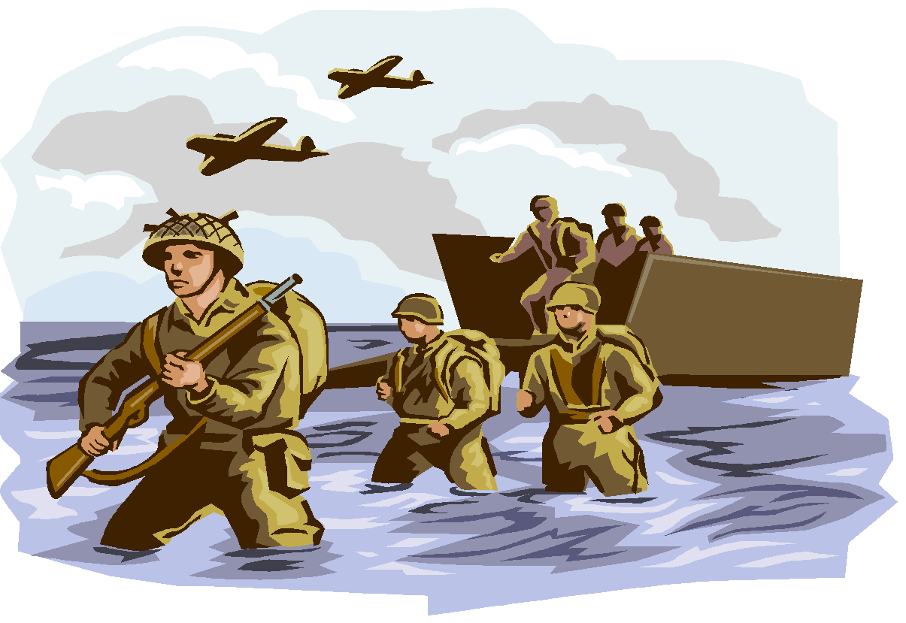
  - Prelude to War (1933-1939)
  - The Course of World War II
  - The New Order
  - The Home Front
  - Aftermath of the War
- Selected Readings:
  - A Justification of Japanese Expansion, by Ryusaku Tsunoda
  - Two Poems of the Spanish Civil War
  - Report from Guernica
  - The Evacuation of Dunkirk, by Douglas Williams
  - The Battle of Britain, by Mrs. Robert Henrey
  - A German Soldier at Stalingrad, by William Hoffman
  - The Informed Heart: Nazi Concentration Camps, by Bruno Bettelheim
  - Witness to the Holocaust, by Fred Baron
  - Race and Space, by Doris Bergen
  - Speech to the House of Commons, June18,1940, by Winston Churchill
  - The Nuremburg Laws, 1935
  - The Jewish Question as a World Problem, by Alfred Rosenberg

Week 31:
- CHAPTER 28: Cold War and a New Western World, 1945-1965
  - Development of the Cold War
  - Europe and the World: Decolonization
  - Recovery and Renewal in Europe
  - The United States and Canada: A New Era
  - Postwar Society and Culture in the Western World
- Selected Readings:
  - The Truman Doctrine and Marshall Plan
  - The Cold War: A Soviet Perspective, by B.N. Ponomaryov
  - The Cominform Defines Conflict Between the USSR and the U.S.
  - Khruschev Denounces the Crimes of Stalin: The Secret Speech
  - The Berlin Wall, by Jens Reich
  - Declaration Against Colonialism, The United Nations
  - Nonviolence in Peace and War, by Mohandas Gandhi
  - The Balfour Declaration, U.N. Resolution 242, and a Palestinian Memoir
  - Who Started the Cold War? American and Soviet Perspectives
  - The Cuban Missile Crisis from Khruschev’s Perspective

Week 32:
- CHAPTER 29: Protest and Stagnation: The Western World 1965-1985
  - A Culture of Protest
  - A Divided Western World
  - The Cold War: A Move to Détente
  - Society and Culture in the Western World
- Selected Readings:
  - British Labor’s Rise to Power, by Harry W. Laidler
  - The Second Sex and Feminist Manifesto, by Simon de Beauvoir
  - Existentialism and Humanism, by Jean Paul Sartre
  - The Times They Are A-Changin: The Music of Youthful Protest
  - 1968: The Year of Student Revolts
  - Czechoslovakia, 1968: The Two Faces of Communism
  - “Thatcherism and the Free Market, by Margaret Thatcher
  - The Fury of the Red Guards
  - The Limits of Modern Technology

Week 33:
- CHAPTER 30: After the Fall: The Western World in a Global Age (since 1985)
  - Toward a New Western Order
  - After the Cold War: New World Order or Age of Terrorism?
  - New Directions and New Problems in Western Society
  - Western Culture Today
  - Toward a Global Civilization: New Challenges and Hopes
- Selected Readings:
  - The Short Century- It’s Over, by John Lukas
  - The End of the Cold War, by R.L. Garthoff
  - After Communism: Causes for the Collapse, by Robert Heilbroner
  - Terrorism and the Clash of Civilizations, by Samuel P. Huntington
  - Religious Terrorism, by Mark Juergensmeyer
  - Speech on Russia’s Development Strategy through 2020, Vladimir Putin
  - Voices from Chernobyl, by Svetlana Alexievich
  - CNBC European Business, 2008 editorial by Richard Lofthouse
  - Globalization, by Thomas L. Friedman
  - Global Warming, by Elizabeth Kolbert
  - Ecological Threats by J.R. McNeill

Week 34:

- REVIEW, REVIEW, REVIEW
- AP EXAM FRIDAY MAY 6!!

Weeks 35- 38:
- AP Euro Film Festival
- Field Trip: Legion of Honor
- Final projects/exams

Grading System:

Grades are weighted in the following categories:
- Essays (DBQ, LEQ, SAQ): 30%
- Multiple Choice Assessments: 30%
- Assignments and Projects: 40%

Based on recommendations of the College Board, the following scale will be used:

- 90-100%= A
- 80-89%= B
- 70-79%= C
- 60-69%= D
- 0-59%= F

All DBQs (Document-Based Question Essay) will be based on a 7-point scale (no half points). The standards for grading will focus on thesis statement clarity, logic of argument, evidence, outside information provided, etc.

- 7= 100% = A+
- 6= 95% = A
- 5= 85% = B
- 4= 75% = C
- 3= 65% = D
- 2= 55% = F
- 1= 45% = F

All LEQs (Long Essay Question) will be based on a 6-point scale (no half points). There are four different types of LEQs: Causation, Comparison, Continuity and Change Over Time, and Periodization.

- 6= 100% = A
- 5= 92% = A-
- 4= 82% = B-
- 3= 72% = C-
- 2= 62% = D-
- 1= 52% = F

Final Note:
Please remember that this class may be challenging, but at the end of the year, you will find that you have acquired great skills in reading, analysis, critical thinking, and writing. If you try your best and do not fall behind in the homework, success is possible and attainable. If you are struggling with any material or reading, please contact Mrs. Dillon as soon as possible- don’t wait! Best of luck in this school year.

“Europe was created by history. America was created by philosophy.”

- Margaret Thatcher

AP EUROPEAN HISTORY STUDENT CONTRACT

I, _______________, have read and understand the course, rigor, and requirements for success in the class. I promise to try my best and always ask for help when I need it. I understand that this course requires me to pull my own weight and keep up with the assigned reading. I also understand that by preparing for and passing the AP exam in May, I can earn college credit, and therefore will give it my best effort. Finally, I understand that I must be an active participant in the class in order to gain as much knowledge as I can from this course.

Student Signature/Name: __________________________

Parent Name: ___________________ Date: ______________________________

______________________________
Mrs. Paula Dillon, AP European History teacher

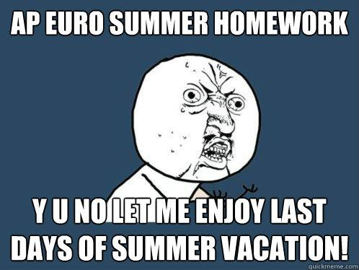

Please type or sign your name on this document and return to me.

