The Hatch Family: The Upper Middle Class by Eastman Johnson (1871)
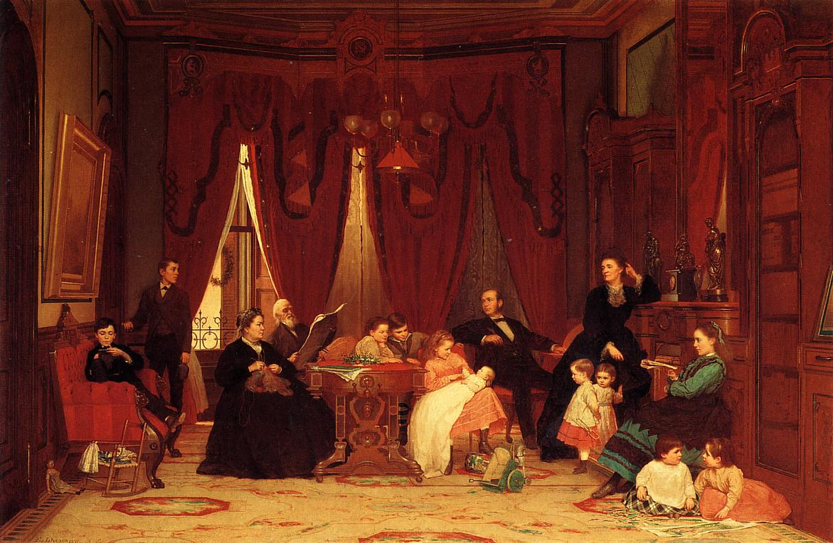

Mid-nineteenth century French engraving: The Ages of Woman
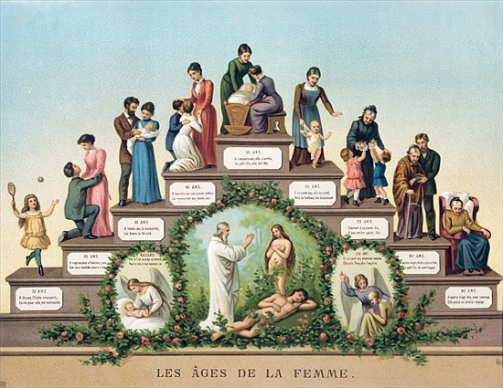

Kathë Kollwitz, Lunch Hour: The Working Class. 1909 Germany.
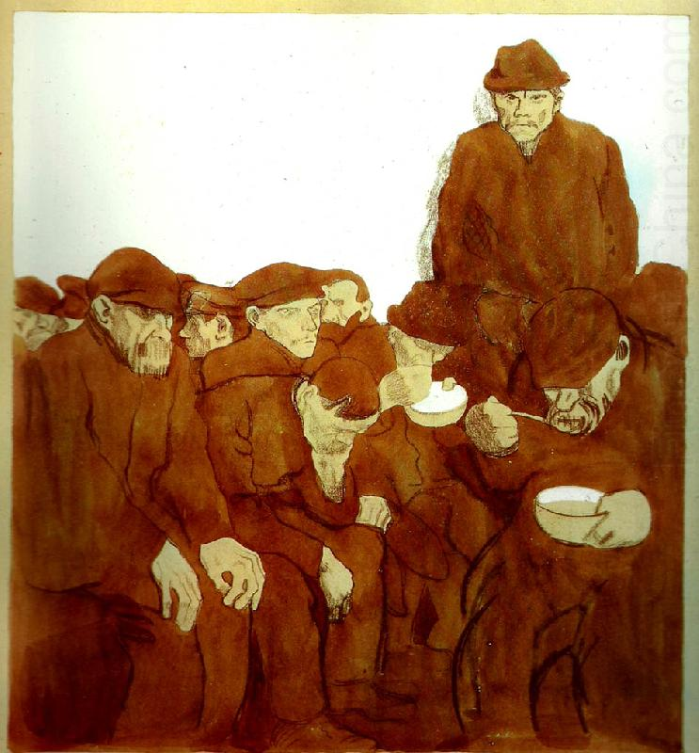

Jacob Steinhardt, 1913. The City. German expressionism.
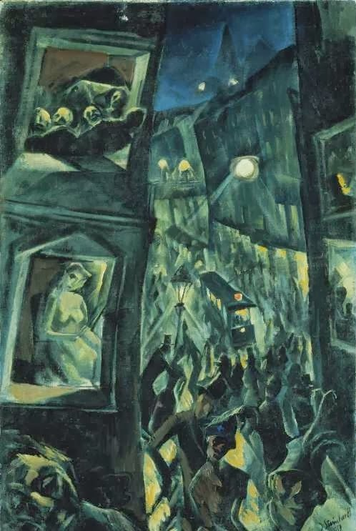

Leon Frederic, Belgium. The Ages of the Worker, 1985.

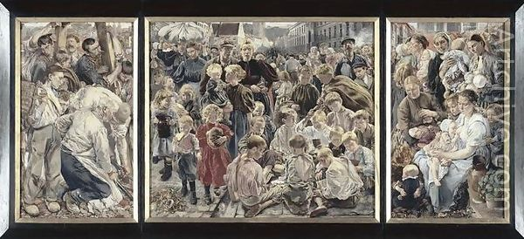

Figure 1: Fawcett’s Liberal appeal for women’s suffrage. Figure 2: The government’s reaction to feminism.
