Early European Exploration and Colonization: 1450-1700

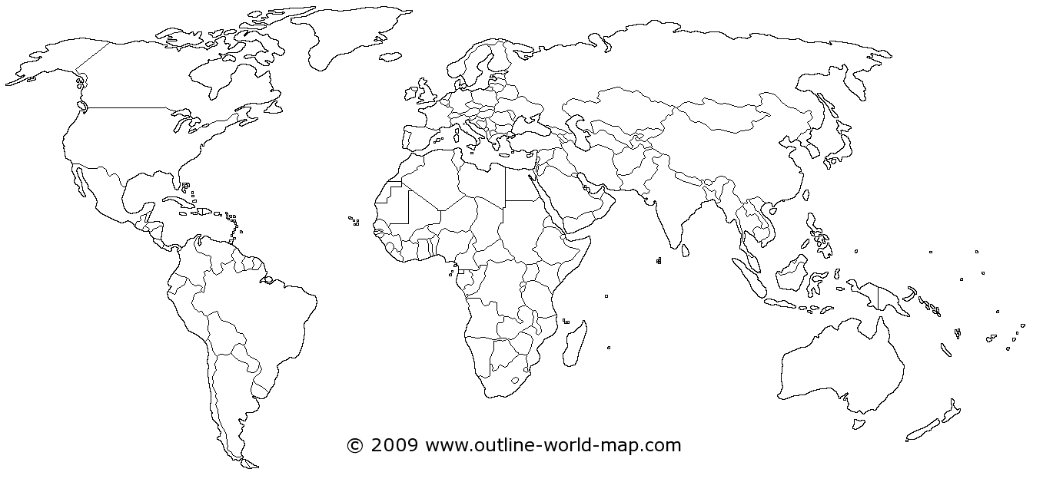
Key: Color and label the following European nations on the map, The economics of empire: For each colonial territory, list the various
and color their corresponding early colonial territories. resources that were desired by European nations and part of
Triangular Trade (Trans-Atlantic Trade):
⃝ England ⃝ Portugal - African Coasts
⃝ France ⃝ The Netherlands - The Spice Islands/East Indies
⃝ Spain - The Americas
- Asia: China, Japan, Southeast Asia

